Febraury 24, 2021

Guidance

DOH defines a farmers market as a physical location with the primary purpose to provide a retail opportunity for two or more vendors that grow, raise, or process local agricultural products to sell products directly to consumers. BFHD considers a market with 50% or more vendors selling mostly local agricultural products as meeting the DOH intent of “primary purpose”. Farmers markets will follow WA DOH Guidance for Farmers Markets, markets or events with more than 50% of vendors selling non-agricultural products will need to also follow Miscellaneous Veues COVID-19 Requirements. Follow Restaurant, Tavern, Breweries, Wineries and Distilleries COVID-19 Requirements when foods are prepared and served onsite. If live entertainment will take place, follow Theater & Perfoming Arts COVID-19 Requirements. A written plan will need to be submitted to contactusfoodsafety@bfhd.wa.gov as part of the Temporary Event Coordinator Application and should include details for health screening, physical distancing, face coverings, and hygiene.
Health Screening (Market Staff, Vendors, & Customers)
Have Vendors and staff follow DOH guidance for daily COVID-19 symptom screening. If staff or vendors feel sick or become sick with COVID-19 symptoms such as fever, dry cough, or shortness of breath, they should be sent home immediately. Vendors or staff that may have been exposed to COVID-19 should be under quarantine at home and not at the market. Consider waiving cancellation fees to help with compliance.
Guidance for Daily COVID-19 Symptom Screening of Staff and Guests
Encourage visitors to self-screen for symptoms before they enter the market. Post signs that remind consumers to stay home when sick.
Signage For Safe Market Operations
Physical Distancing
Booth spacing
DOH requires booths to be spaced at least 6ft. apart unless there is a physical barrier or wall separating booths or tables. Physical barriers, if used, should be at least 6ft. high and have two open sides to allow adequate air flow.
Visitor spacing
Ensure that visitors or groups are able to stay 6ft. apart. Post signs throughout the market that remind everyone to watch their distance.
Farmers Market Capacity
In order to encourage proper physical distancing, market organizers of farmers markets should determine a capacity limit for the market. As an example, King County guidance for farmers markets sets visitor capacity for farmers markets at two people per booth or three per booth if spacing booths 10 ft. apart.

Event Capacity
Markets that also include activities or vendors that are not selling agricultural products need to follow maximum capacity for miscellaneous venues. For outdoor markets, this is set at 200 people and 300 people for very large venues that are over 100,000 sq. ft. in size. To adhere to capacity limits, we recommend staff count visitors that are entering and exiting the event so they know how many are in attendance at a given time by subtracting the the total entered from the total exited. This can be done with minimal staff and clicker counter or phone app.

Recommend designating areas using fencing and one-way traffic to cordon off areas of a market - such as food vendors selling ready to eat food so those customers are not included toward market capacity.
Hygiene
Face coverings
Provide signs at entrances and exits to encourage compliance with face covering rules. Customers must wear a face covering anytime they are not actively eating or drinking. Other than during sampling, customers must be seated when eating or drinking following restaurant requirements.

DOH guidance - “Businesses have the right to refuse service and are encouraged to not serve customers or visitors who aren’t wearing face coverings. Businesses can offer accommodations such as curbside pick-up or delivery. “
Face Masks or Cloth Face Covering
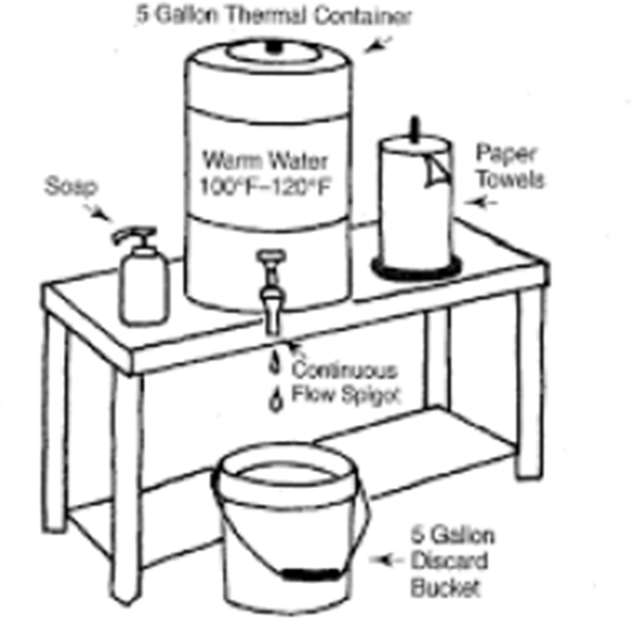
Hand hygiene
Make sure staff and visitors have the means to clean their hands. Provide temporary portable handwashing stations, or alcohol-based hand sanitizer dispensers for use by staff, volunteers, and visitors.

Farmer’s market plans will be approved only on a contingency basis.

Under the following circumstances, Benton-Franklin Health District can require the market to discontinue:
- BFHD receives a number of legitimate complaints regarding a lack of compliance;
- There is a lack of follow-up with identified issues; or
- There are reports of exposures to COVID-19, or of illnesses resulting from exposure and failure to manage the situation.
- The COVID-19 safety management plan is not being followed.

